
Provincial Grand Senatus of Surrey
‘Thornbury’
3 Heath Drive
South Sutton
Surrey, SM2 5RP
Telephone: 07702 570736
E-Mail: cw.eley@talktalk.net
Dist.Comp. Christopher W Eley IV
Deputy Provincial Grand Summus 12th May 2026
The Provincial Grand Summus,
Right Distinguished Companion Nigel Thomson,
requests your attendance at the Annual Meeting of the
Provincial Grand Senatus of Surrey
To be held at the
Surbiton Masonic Hall
Glenmore House, 6 The Crescent, Surbiton, Surrey, KT6 4BN on
Thursday the 16th of July 2026 at 11.15 am.

Lunch at 1.30 pm
Menu
Trio of Smoked Salmon Blini, Mushroom Parfait Crouton, and Mini Panko Brie
Chargrilled Supreme of Chicken served over McSweens Haggis,
Fine French Beans, Rosti Potato and a Light Whisky Cream
Classic Bread & Butter Pudding with a Creamy Custard
OR Cheese & Biscuits (if pre ordered #)
Fair Trade Coffee or Tea and a Glenmore Chocolate
Fine Red & White Wines
The dining fee inclusive of wine is £39.00
(# plus £2.50 for cheese & biscuits alternative to dessert)
Please advise me of any Special Dietary Requirements
R.S.V.P. to Dist.Comp. Chris Eley, Deputy Provincial Grand Summus - by 30th June 2026
Our Provincial Grand Summus hopes that as many Companions as possible will be able to attend.
Yours sincerely and fraternally,
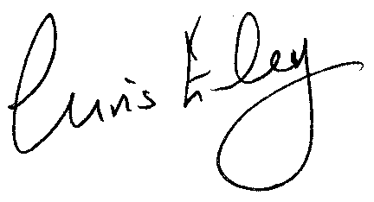
Dist.Comp. Chris Eley IV
Deputy Provincial Grand Summus
Provincial Grand Senatus of Surrey
Annual Meeting to be held on Thursday 16th July 2026 at 11.15 am at the
Surbiton Masonic Hall, Glenmore House, 6 The Crescent, Surbiton, Surrey KT6 4BN.
Attendance Notification and Lunch Booking Form
To: Chris Eley, 3 Heath Drive, South Sutton, Surrey, SM2 5RP
E-Mail: cw.eley@talktalk.net
From: (Initials & Surname)
Consistory Name and Number:
Scarlet Cord Rank:
Please tick the appropriate boxes
I will attend and dine with _______ guests (Please advise names, Consistory, and Ranks)

I would like dessert OR Cheese and Biscuits at additional cost

I will attend the meeting but will not dine

I am not able to attend the meeting nor dine – please give my apologies

Enclosed is my cheque for £__________ @ £39.00 per person (£40.50 if cheese & biscuits)
Please make cheques payable to Provincial Grand Senatus of Surrey.
Or by Bank Transfer to Provincial Grand Senatus of Surrey
Sort Code 60-05-29. Account Number 22088504; and advise Dist.Comp. David Willmott, Provincial Grand Treasurer, by email on dandaw38@outlook.com with copy to cw.eley@talktalk.net

Any dietary requirements:

Signature: ………………………………………………. Date:

