GRAND COUNCIL OF THE ORDER OF THE ALLIED
MASONIC DEGREES OF ENGLAND AND WALES
AND DISTRICTS AND COUNCILS OVERSEAS

Most Worshipful Brother Thomas Firth Jackson
Grand Master

District Grand Council of Surrey

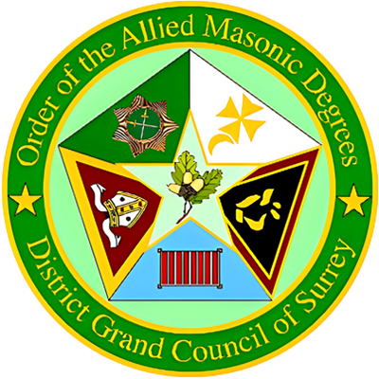

R.W. Bro. John Vaughan Christopher French
District Grand Prefect

W. Bro. Robert G Tuthill, P.G.S.D.
Deputy District Grand Prefect

Dear Sir and Brother, October 2026
By Command of the Right Worshipful District Grand Prefect the

ANNUAL MEETING OF DISTRICT GRAND COUNCIL
will be held at 11:00 am at the Croydon and District Masonic Hall
73 Oakfield Road, Croydon, Surrey, CR0 2UX
on Saturday 5th December 2026

The District Grand Officers and the Masters, Wardens, Past Masters and other members of Councils in the District are summoned to attend.

Yours faithfully and fraternally
Trevor Sadler
District Grand Secretary

Brethren are requested to be seated by 10.40 am
District Executive
and District Grand Officers
2025 – 2026

District Grand Prefect | R.W. Bro | John V C French
Deputy District Grand Prefect | W. Bro. | Robert G Tuthill, P.G.S.D.
District Grand Senior Warden | W. Bro. | Michael J Mello
District Grand Junior Warden | W. Bro. | Denis D Leigh
District Grand Chaplain | W. Bro. | Leslie Grout, KCLJ, P.G.St.B.
District Grand Treasurer | W. Bro. | Raymond M S Seeley
District Grand Secretary | W. Bro. | Trevor J Sadler
District Grand Dir of Ceremonies | W. Bro. | William R Barr
District Deputy Grand DC | W. Bro. | Miguel A J Godfrey
District Grand Senior Deacon | W. Bro. | Kevin P Brennan
District Grand Junior Deacon | W. Bro. | Colin M Beerling
District Asst Grand DC | W. Bro. | Stephen B P Dingvean
District Grand Sword Bearer | W. Bro. | Richard J Wileman
District Grand Standard Bearer | W. Bro. | Stuart J Hogarth
District Asst Grand Secretary | W. Bro. | David T Clark
District Grand Organist | W. Bro. | Robert A Soper
District Grand Inner Guard | W. Bro. | Bernard J Greenwood
District Grand Steward | W. Bro. | Raymond R Johnson
District Grand Steward | W. Bro. | Alan J White
District Grand Tyler | W. Bro. | Alan M Hall, P.Dist.G.J.W.

Business before District Grand Council

District Grand Council will be opened in due form.
To honour the names of those Brethren who have passed to the Grand Council Above since the previous Annual Meeting.
The Right Worshipful District Grand Prefect will welcome the Honoured Guests.
The Minutes of the Annual Meeting of District Grand Lodge held on 6th December 2025 will be put for confirmation.
The Roll of Officers of District Grand Council will be called.
The Roll of Councils in the Province will be called.
The Right Worshipful District Grand Prefect will welcome the Newly Admitted Brethren.
The District Grand Treasurer will present his Report. The Accounts for the year ending 31st August 2026 will be submitted for approval and adoption.
To receive the Annual Report from The District Grand Secretary.
The District Grand Treasurer will be elected.
The District Grand Treasurer will propose an increase in District Subscriptions and Honour Fees from 1st Sept 2027.
Two Brethren to serve on the Audit Committee for the ensuing year will be elected.
The District Grand Master will announce the re-appointment of:
W. Bro. Robert G Tuthill P.G.S.D. As DEPUTY DISTRICT GRAND PREFECT.
The Right Worshipful District Grand Prefect will Appoint and Invest the District Grand Officers, those receiving Promotions and Past.
The Right Worshipful District Grand Prefect will address District Grand Council.
A Charity Collection will be taken.
Any other Business.
The Grand District Council will be closed in due form.

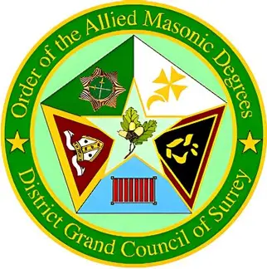

Order of the Allied Masonic Degrees

District Grand Council of Surrey

Croydon Masonic Hall, 73 Oakfield Road, Croydon, Surrey CR0 2UX
Saturday 5th December 2026 at 11:00 am (seated by 10:40 am)

ATTENDANCE NOTIFICATION
Dining Fee £43.00
(each, inclusive of wine/soft drink)
(Please submit a Temple Reservation Booking even if you are not Dining)

MENU
Prawn & Mango Cocktail with Brown Bridge Roll
------
Breast of Chicken in White Wine Sauce
------
Lemon Meringue Pie
------
Wines: Fallow’s View South Africa Red and Fallow’s View South Africa White

Lunch will be served at approximately 13:30hrs
Bars are available after the close of District Grand Council for Brethren of the District, their personal guests and for the Present and Past District Executive, Right Worshipful Brethren and the Guests of the District.

The Closing Date for Lunch Applications is
Friday, 27th November 2026 – so please book early to avoid disappointment.

Booking Link: >>>> BOOK HERE <<<<

Cancellations to be made by email to: d.clark@btinternet.com
Refunds only for written cancellations received before 28th November 2026
CAR PARKING at CDMH is by TICKET ONLY
To apply, please select the option when making your reservation
Special needs and car sharing will be prioritised
Allocated Car Park Tickets will only be issued after the 28th November

www.surreycompanionorders.com

PLEASE COMPLETE THE INFORMATION BELOW AND RETURN ONLY THIS PAGE WITH YOUR PAYMENT

District Grand Council of Surrey

Croydon Masonic Hall, 73 Oakfield Road, Croydon, Surrey CR0 2UX
Saturday 5th December 2026 at 11:00 am (seated by 10:40 am)

From (Initials & Surname) RANK
Allied Council Name & Number
Tick the appropriate box and provide your e-mail address: ____________________
I Shall Attend and Dine |  | I Shall Attend but NOT Dine |  | I Send my Apologies
I wish to dine with members of Allied Council Name & Number
Please indicate any special dietary requirements – changes cannot be made on the day
Payment of Dining Fee £43.00 (each, inclusive of wine/soft drink)
Returns and payments to: D Clark, 50 Fairlawnes, Malden Road, Wallington, Surrey, SM6 8BG
Electronic transfer (preferred): Sort Code: 30-90-44 Account No: 00741683 Reference: AM26 with your Name and Council Number. Please email confirmation of payment to d.clark@btinternet.com or send a cheque payable to the District of Surrey AMD and posted to the above address.
The Closing Date for Dinner Applications is
Friday 27th November 2026 – book early to avoid disappointment
Cancellations to be made by email to: d.clark@btinternet.com
Refunds only for written cancellations received before 28th November 2026

